<https://www.youtube.com/watch?v=ruz-vK8IesE>

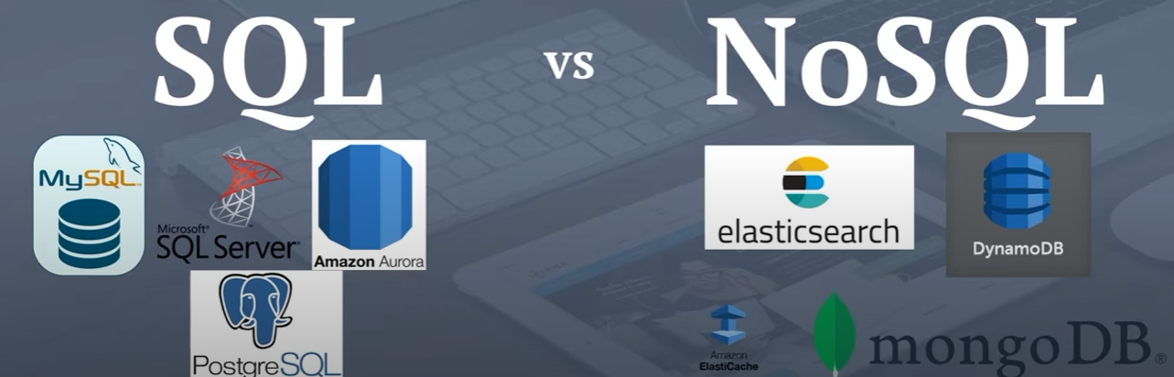

SQL